

**Southern Leyte State University**

San Juan Campus

San Jose, San Juan, Southern Leyte

**LEYTE SOUTH MULTI PURPOSE COOP**

**HOTEL & RESTAURANT**

**ORDER/BOOKING SYSTEM**

Submitted By:

**SERVANDO S. TIO III BSIT 3-A**

Submitted to:

**EMANNUEL T. SALIGUE**

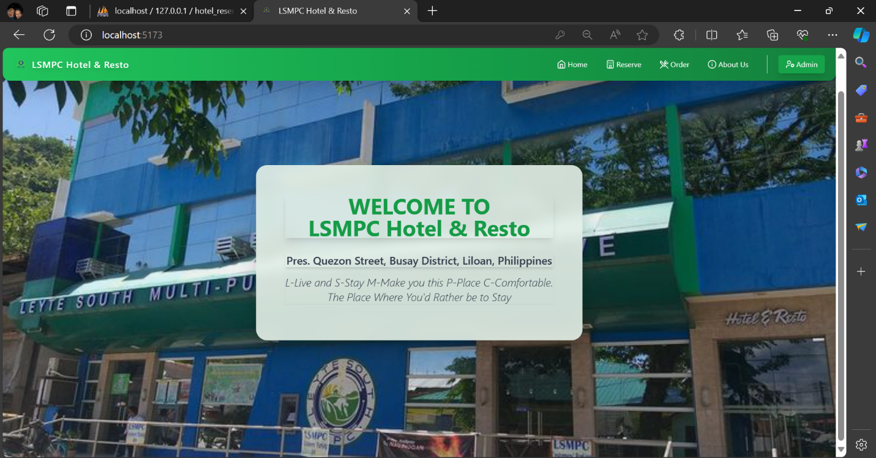

**HOME DASHBOARD**

The Home Dashboard will be opened first when the system is started and the following navbar are the routes of each form for the system and the background image is a slideshow with different images.

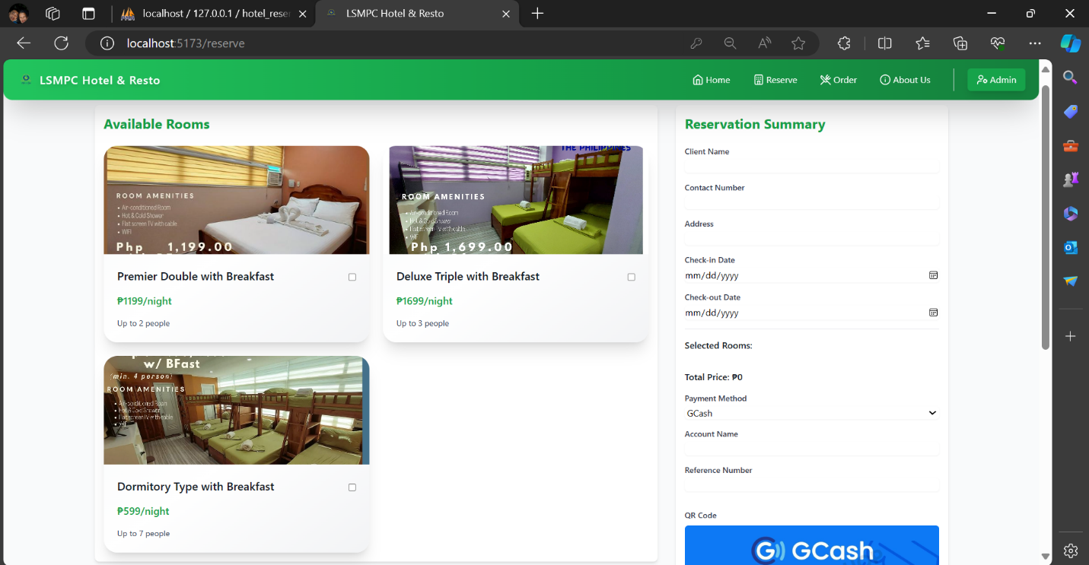

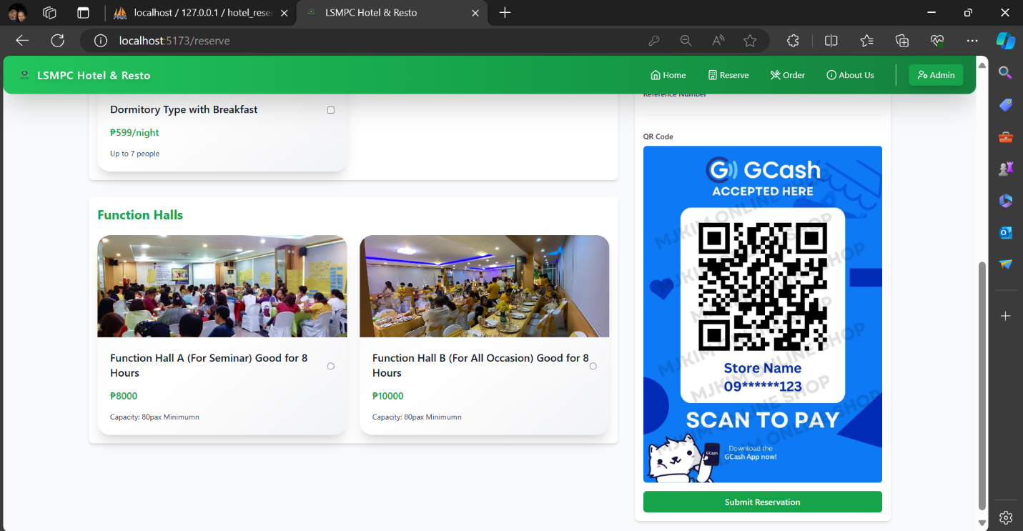

**RESERVE DASHBOARD**

The Reserve Dashboard cater the booking/reservation of 3 types of room and 2 types of function hall in the hotel/resto.

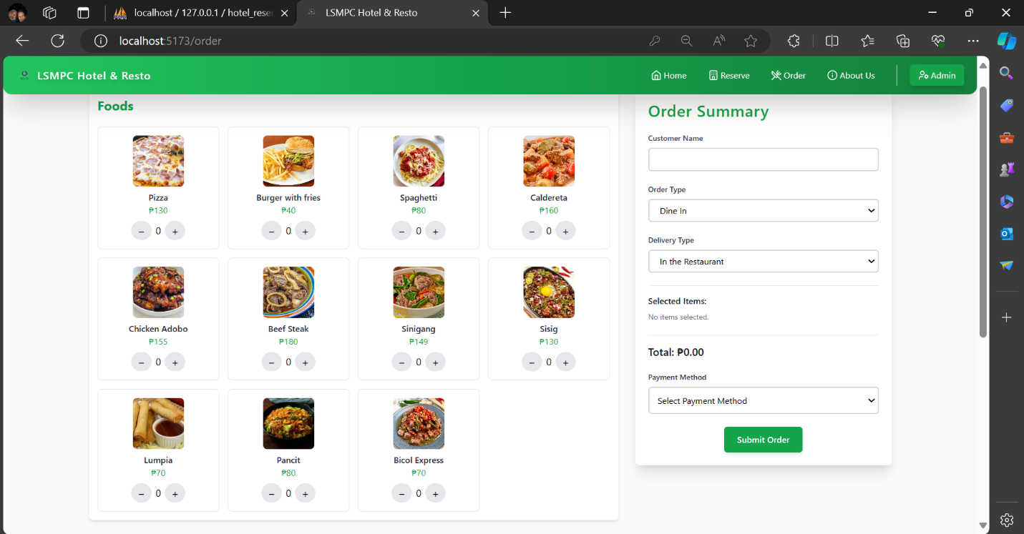

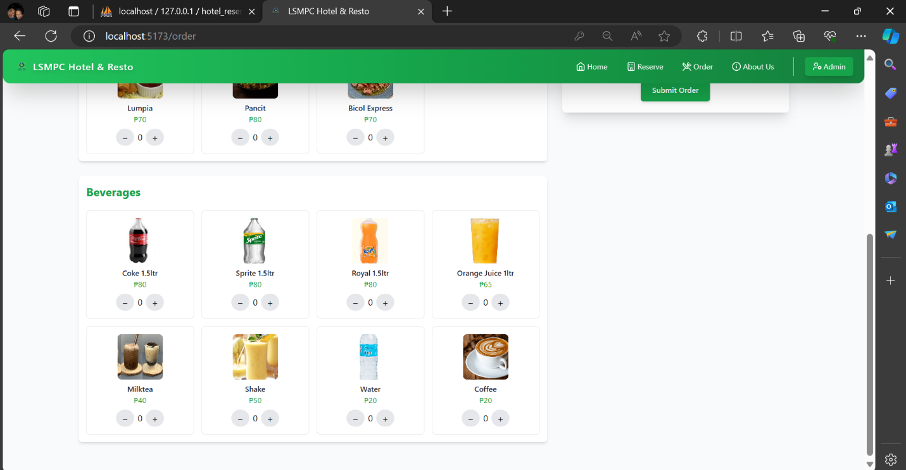

**ORDER DASHBOARD**

The Reserve Dashboard cater the booking/reservation of 3 types of room and 2 types of function hall in the hotel/resto.

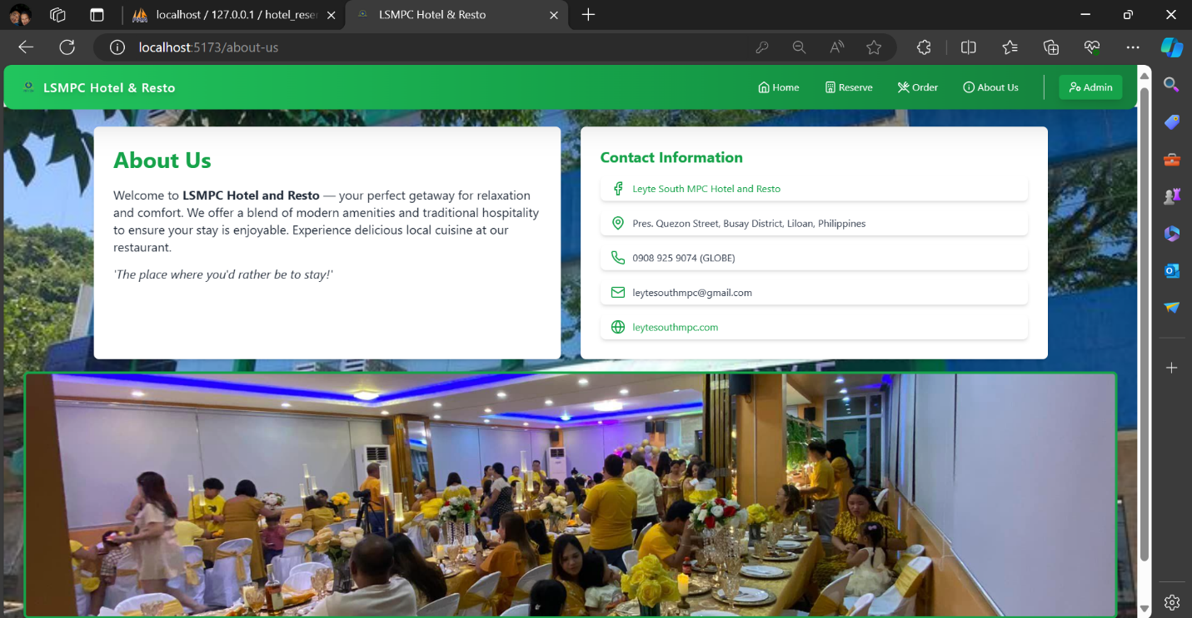

**ABOUT DASHBOARD**

The Reserve Dashboard cater the booking/reservation of 3 types of room and 2 types of function hall in the hotel/resto.

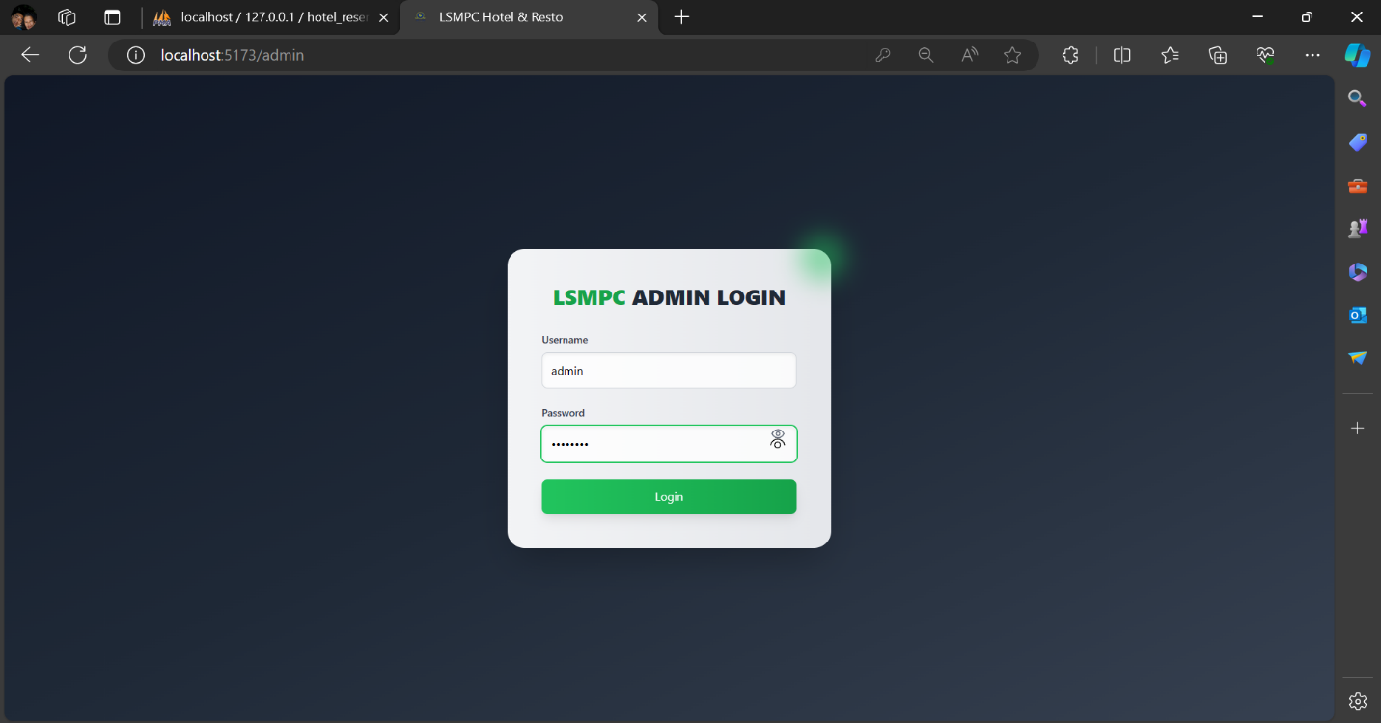

**ADMIN LOGIN DASHBOARD**

This is the login form to be able to access the admin dashboard that will see the current sales.

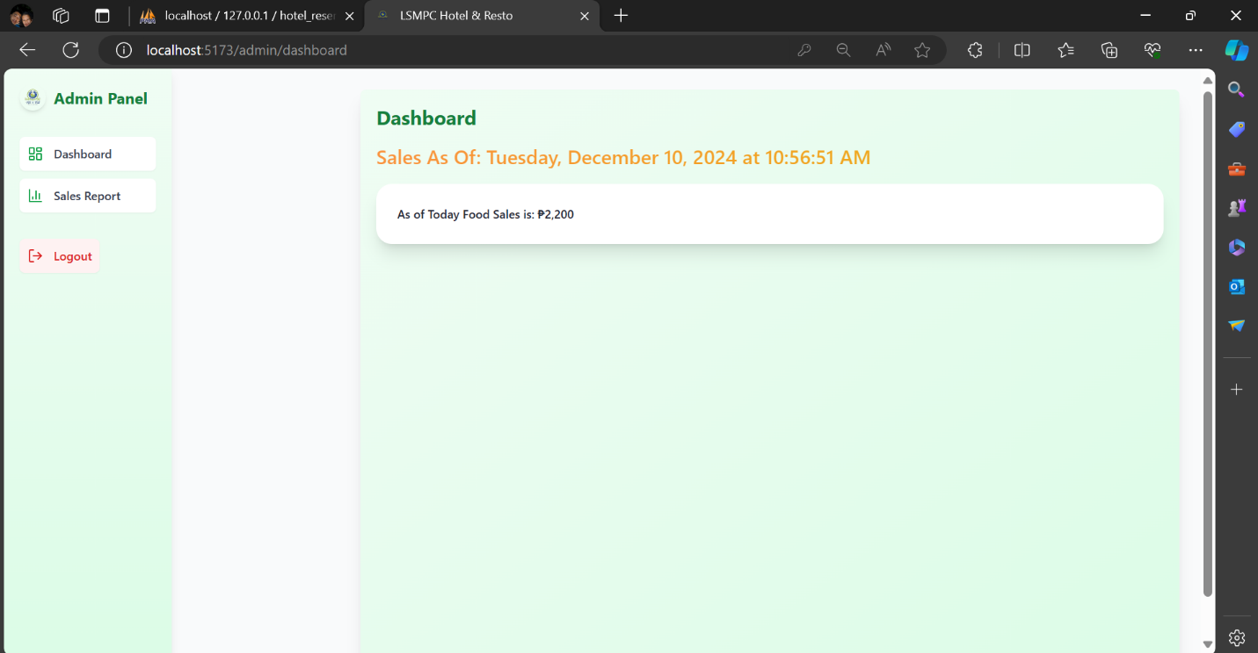

**ADMIN DASHBOARD**

The admin dashboard will see the current Food sales total amount

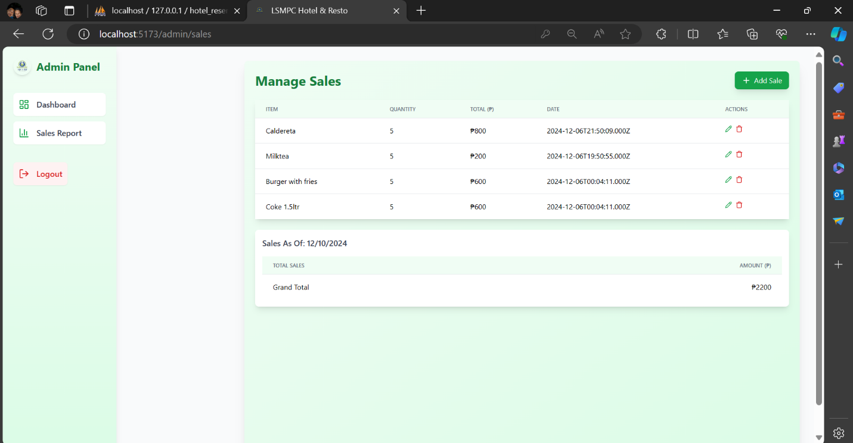

**SALES REPORT DASHBOARD**

The sales report dashboard will see the current items have been sold with the current total amount of sales.

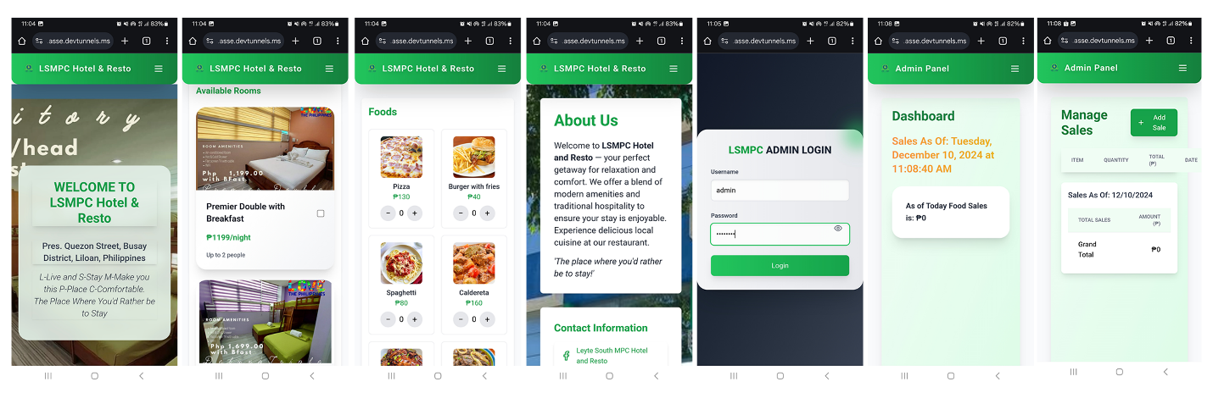

Also, the forms are cross compatible both mobile and desktop devices

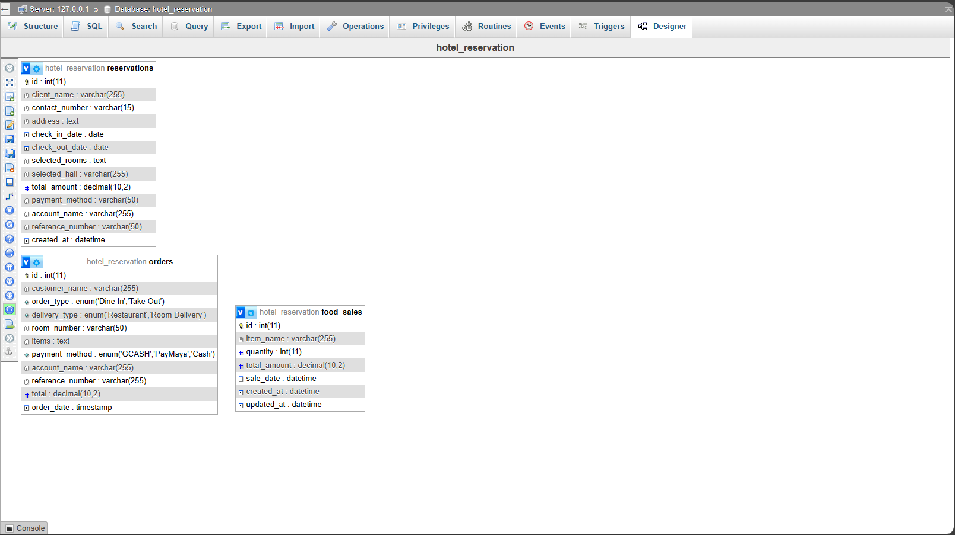

**ERD DESIGNER**